Which of the following displays a code which iterates from numbers 1 to 100, displays “fizz” if the number is divisible by *a* but not *b*, displays  
    “buzz” if the number is divisible by *b* but not *a* and displays “fizzbuzz” if the number is divisible by both*a* and *b.* *a* and *b* are  
    inputs taken from the user.

  
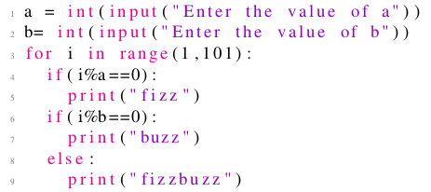

  
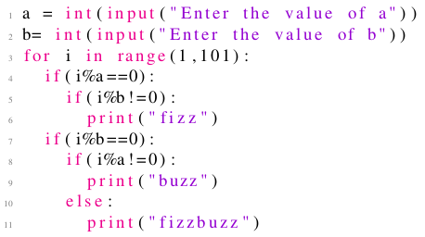

  
  
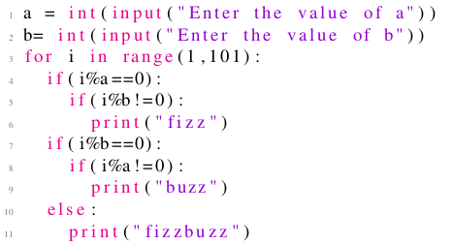

  
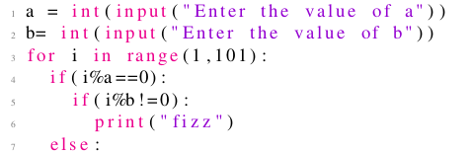  
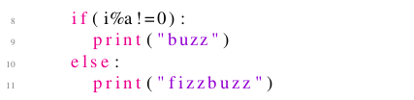

***1 point***

The below code displays  
  
 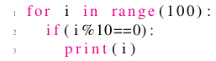

 all numbers from 1 to 100 which are divisible by 10

 all numbers from 1 to 99 which are divisible by 10

 all numbers from 1 to 110 which are divisible by 10

 none of the above

***1 point***

What is the output of the following code?  
  
 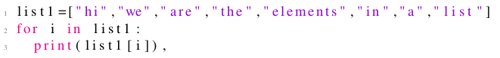

 hi hi hi hi hi hi hi hi

 hi we are the elements in a list

 hi

 error

***1 point***

What is the output of the following code?  
  
 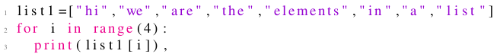

 hi we are the elements in a list

 hi we are the elements

 hi we are the

 hi we are

***1 point***

Which of the following correctly represents a sum function in Python.

  
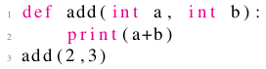

  
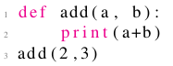

  
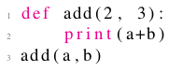

  
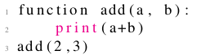

***1 point***

Which of the following statements correctly represents a jumbled form of a given word. For example, if the word=“lion”, one of the plausible  
    outputs can be “oinl”.

 "".join(random.sample(word,len(word)))

 "a".join(random.sample(word,len(word)))

 "".join(random.sample(word))

 join(random.sample(word))

***1 point***

Given a variable word which is a string where no letter is repeated, what does the following code snippet do?  
  
 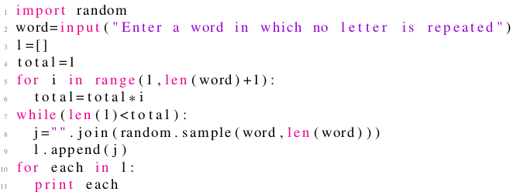

 keeps printing the jumbled form of the word in an infinite loop

 shows all the jumbled forms of the word where some forms might be repeated

 shows some jumbled forms of the word where some forms might be repeated as well

 shows all unique jumbled forms of the word including the original word as well

***1 point***

Assuming, there is no file named "file.txt" on my computer, what does the following code do?  
  
 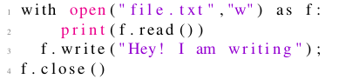

 Creates a file named file.txt and adds “Hey! I am writing” to it

 Shows an error because file does not exist

 Shows an error because file in not opened in the reading mode

 None of the above

***1 point***

Assuming, there is no file named "file.txt" on my computer, what does the following code do?  
  
   
 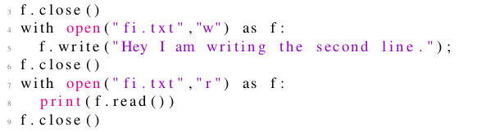

 Shows error

 Displays: Hey I am writing the second line

 Displays: Hey! I am writing.Hey I am writing the second line.

 Displays: Hey! I am writing.

***1 point***

What is the output of the following code?  
  
 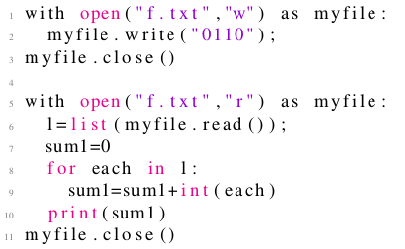

 Displays 1

 Displays 2

 Displays 0

 Shows error